# Product Knowledge for new starters

*Note: this document has been prepared as a starting point for new Advisors and CSMs. The online Product Wiki is your complete up-to-date reference on how Maths-Whizz works. The Bare Essentials complements this guide and looks at the principles behind Maths-Whizz (why it exists), Maths Age and the Tutor. It also delves into the core user journey for teachers.*

1. Product components 2

2. The Maths-Whizz curriculum 3

3. Content 4

4. How the Tutor works 5

4.1 Assessment 5

4.2 Learning journey 6

4.3 Topic Focus 7

4.4 Progression 7

4.5 Jumping 7

4.6 Skipping exercises 8

4.7 Regression 8

4.8 Static 8

4.9 Summary of how the Tutor works 8

5. Student Experience 9

5.1 Study 9

5.2 Console 9

5.3 Topic Bank and Replay 9

5.4 Challenge 10

5.5 Credits 10

5.6 Shop, Play Area and Lock 10

5.6 Weekly Usage Journey 10

6. Reports 11

6.1 Reporting period and Timespan 11

6.2 Key metrics 11

6.3 Student Reports 12

6.4 Parent reports 13

6.5 Calculating for groups of students: Averages 13

6.6 Class Reports 13

6.7 School reports 14

6.8 Central Reports 15

6.9 Automated fortnightly emails 16

6.10 Key Actions 16

6.11 Usage and Progressions guidelines 17

7. Teachers’ Resource 18

7.1 Lessons 18

7.2 Mixed Tests 19

7.3 Interactive Board and Extension Problems 19

7.4 Examples of other tools 19

8. Parent Experience 19

9. Admin 19

10. Technology 19

## 1. Product components

Maths-Whizz is the virtual tutoring service created by Whizz Education to raise standards in mathematics. There are four components to the Product, different parts of which are available to different users:

* **The Maths-Whizz virtual tutor** simulates the behaviour of a human tutor and is available to students around the world. It systematically embeds core knowledge and skills by individualising the learning journey according to each child’s needs and pace of learning.

Every student has a unique login, which the Tutor can then use to track their progress and deliver targeted content.

* As the Tutor interacts with students online, it automatically captures their learning interactions and feeds back **real-time reports** to parents and teachers, which they can use for lesson planning and monitoring.
* Schools also get site-wide access to **Teachers’ Resource**; a flexible range of instructional tools for the classroom, including a library containing all 1250 Maths-Whizz lessons.

Teachers can access both the reports and TR using a site-wide login. Individual teacher logins can be added manually by CS. Parents access reports through their own logins.

* Groups of schools (e.g. Multi-Academy Trusts) can access **Central Reporting** across their entire student base. These reports are also available to Advisors and CSMs and are vital to monitoring usage and progress across your schools.

Central Reports requires a separate user login.

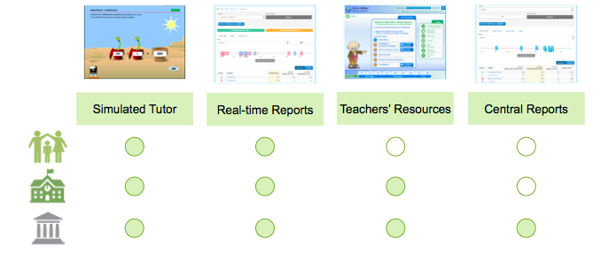

## 2. The Maths-Whizz curriculum

The Maths-Whizz curriculum covers Foundation through to the end of Year 8; we have long-term plans to extend the curriculum to GCSE.

A team of educationalists decided that the best way to help students learn maths is to divide the knowledge they need into 22 topics. In each topic, they listed a set of learning objectives, in increasing order of difficulty, and placed these learning objectives in different years, and then in quarters within those years. For example, Fractions will have lessons for Age 7, starting with lessons in 7.00-7.25, then 7.25-7.50, 7.50-7.75 and finally 7.75-8.00. There are over 1250 learning objectives in the Maths-Whizz curriculum.

The diagram below is for illustration only: the scale corresponds to the age at which the student is expected to have completed each learning objective. In this example, students are expected to start Place Value at age 5, and then continue through to age 14. Fractions starts later and Measures finishes earlier.

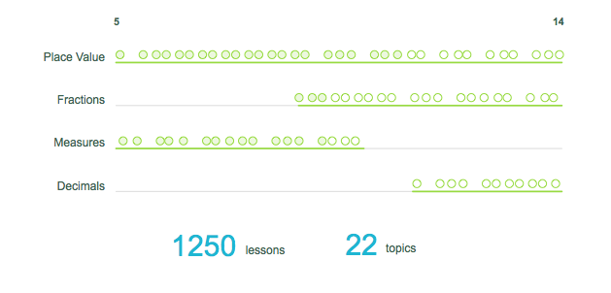

**How close is the Maths-Whizz curriculum to existing curricula?**

For the 2014 National Curriculum for England, the Maths-Whizz curriculum:

* Covers 96% of all required learning objectives
* Contains only a handful of lessons that are not in some way relevant (these are listed in the Curriculum Reports)

In other words, Maths-Whizz is strongly aligned to the National Curriculum. As you’ll see in the Bare Essentials, the most important alignment of all is to the child’s ability, which the Tutor guarantees throughout.

## 3. Content

Maths-Whizz lessons typically contain three parts:

1) Teaching section: the concept or method is explained to the student with a clear, visual animation.

2) Interactive exercise: a set of questions (usually 10). When students input a wrong answer, a Help is provided, which prompts students with a reminder of the underlying method or concept.

If the student exits an exercise early, or loses connection, they restart the same exercise the next time they log in.

Most exercises have randomised question banks, so different questions come up with each attempt at the exercise, ensuring students are answering questions as a result of their understanding. Some exercises rely on fixed questions that are specific to the learning objective.

3) Test: usually 5 questions, no help provided so students have to demonstrate their understanding

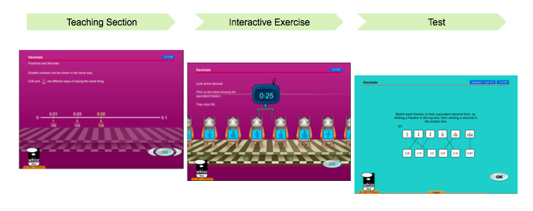

So the Tutor provides scaffolded support to ensure students are appropriately guided throughout the whole lesson.

As we’ll see in the Tutor section, students only move along in a Topic when they have passed both the exercise and test. Some lessons do not have a test (e.g. Rapid Recall).

Maths-Whizz lessons rely on strong visual representations and animations – they are both educationally powerful and highly engaging. The tests are designed to look plain in order to simulate real-life test formats.

Teachers’ Resource has other types of content, such as Extension Problems, which complement the core knowledge and skills students receive through the 1250 lessons in the Tutor.

## 4. How the Tutor works

The Maths-Whizz Tutor behaves like a human tutor by

* Diagnosing students’ learning needs across topics with an initial assessment
* Delivering an individualised learning plan tailored to each child’s specific knowledge gaps, which is constantly updated depending on the progress they make

### 4.1 Assessment

When a student first signs up to Maths-Whizz, they complete an initial assessment designed to identify their current knowledge level across different topics.

The assessment guides students through several topics and pinpoints their level in each topic by giving them a series of short tests. The assessment is adaptive: the questions get harder if the student gets them right and easier otherwise. The student is set a Maths Age for each topic, which is the quarter they end up in (e.g. 7.25 years).

The assessment usually covers 4-10 topics; it isn’t practical to assess students in all 22, so the Tutor makes a ‘best guess’ on the unassessed topics, ignoring those it thinks are too easy or too advanced for the student based on the results achieved in the assessed topics.

It then calculates an overall Maths Age as the average. In the reports, assessment results will appear as follows:

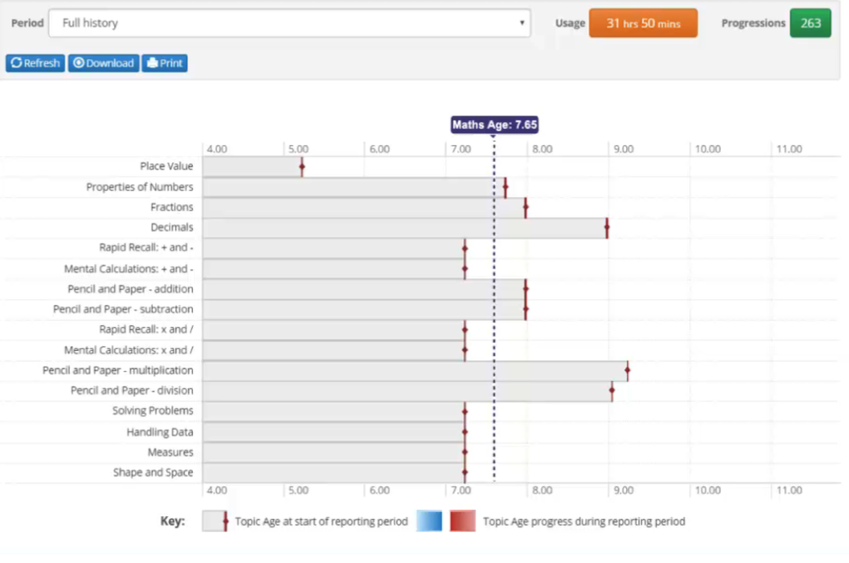

The assessment takes an average of 50 minutes (less for students with a lower Maths Age as there are fewer topics to cover – it also depends on the student’s own pace of answering questions).

The Tutor uses the student’s learning profile to plan their unique learning journey.

### 

### 4.2 Learning journey

The Tutor delivers lessons in sequence based on each child’s learning needs. The student above will get more attention in Place Value, since it is their biggest area for development. In general:

* The Tutor is aiming to get students to the same overall level/Maths Age in each topic (“rounded learning profile”) so that they have no core knowledge gaps.
* The Tutor does not deliver the same topic twice in a row (unless Topic Focus is set – see Section 4.3).
* Students only move forward in a Topic when they have completed the learning objective (i.e. passed the exercise and test).

Note: some topics have more lessons than others, and Topics with more lessons will also tend to appear more often.

As students progress through each topic, blue bars appear to show their progress:

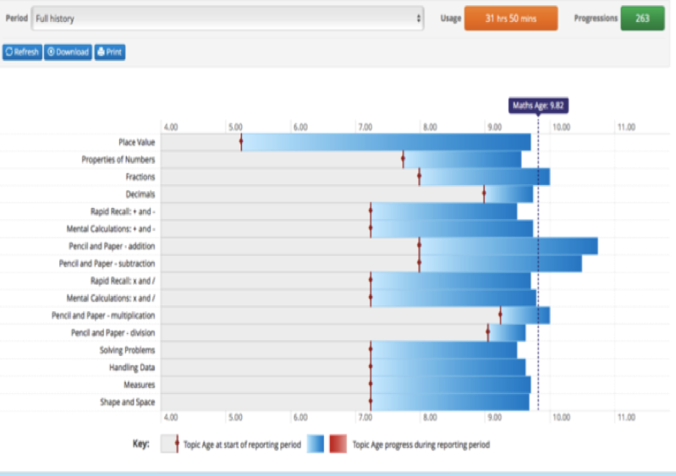

The red lines represent their Maths Age at the start of the reporting period, and the blue bars show their Maths Age improvement in the given reporting period.

Note: some topics in the learning profile may not have appeared in the initial assessment, e.g. Probability will not appear in the assessment for a student with Maths Age 7, but will appear during their learning journey when their Maths Age reaches 12.

Note: red bars only appear when a reassessment has taken place during the reporting period, and the student was assessed at a lower level to where they were at the start of the reporting period (this is common at the start of the academic year, where summer learning loss leads to a negative Maths Age Improvement).

### 4.3 Topic Focus

Teachers can direct the Tutor to any topic of their choice, setting a deadline within 7 days. When students log in, they all receive that Topic only, up to a maximum of 3 Progressions (at which point they continue in Tutor as normal). True to its promise of differentiation, students each receive different lessons based on where they are in that topic.

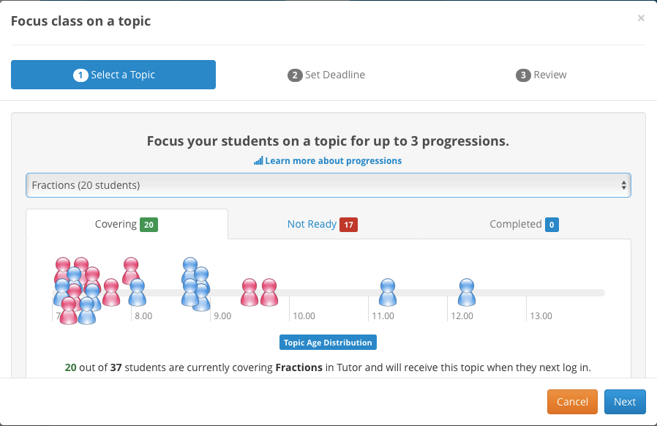

If a student is not ready for the Topic, the Tutor will continue to fill their gaps in other areas. If they have completed the whole Topic, it will continue to stretch them in other areas.

### 4.4 Progression

Students only move along in a Topic when they pass the exercise and test.

* Exercise: 70% is a pass, 30%-69% is static (neither a pass or a fail) and less than 30% is a fail
* Test: 60% is a pass

When students progress along a Topic, their Maths Age goes up slightly (by up to 0.25 years if it is the only lesson in the current quarter, otherwise less than 0.25 years).

Note: some lessons have an exercise but no test, in which a Progression is achieved just by passing the exercise.

### 4.5 Jumping

Over 800 exercises have Jumping enabled, which allows students to pass after just a few questions if they meet the lesson’s pass criteria (different lessons have different criteria based on their respective difficulty). The remaining 450 exercises do not have Jumping enabled because the questions evolve through the exercise, so students may lose vital learning if they skip the questions. Tests do not have Jumping because they are a vital check for understanding and are relatively short anyway.

If students have resumed an incomplete exercise, they start from Q1, but the Tutor remembers their progress from last time and the Jumping policies are in tact, taking into account all questions answered previously.



### 4.6 Skipping exercises

Parents and teachers can skip exercises on behalf of the student if they feel it is not appropriate (e.g. because they feel it is too easy for the student, or has a bug). It will be marked as 70% and a pass, so skipping should be used sparingly. Students must still attempt the corresponding test to check for understanding.

### 4.7 Regression

When students fail an exercise, they are taken to a remedial lesson that fills their knowledge gap. Every exercise has an assigned regression lesson, carefully selected by our educationalists. Students can also ‘Jump Backwards’, where they are automatically sent to regression after struggling with the first few questions.

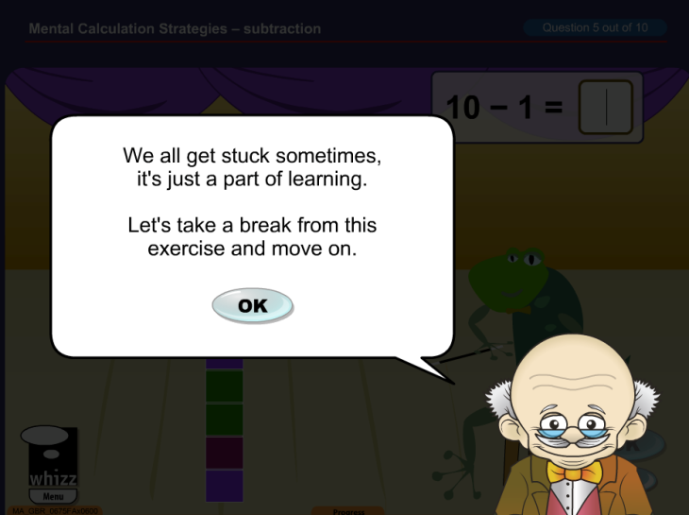

The Tutor can ‘regress’ up to two lessons backwards. If students are perpetually stuck on this final lesson, it is advised that parents/teachers intervene (they can flag up these instances in the student’s Lesson History).

### 4.8 Static

There are two ways to be ‘static’ in a Topic: a) Fail a test, in which case students are taken back to the corresponding exercise and b) Score a static mark (between 30% and 70%) in the exercise, in which case the same exercise appears the next time students visit the Topic.

### 4.9 Summary of how the Tutor works

The tutoring algorithm has two main elements:

* Choosing a ‘Topic Line-up’ that prioritises topics based on the goal of a rounded learning profile
* Delivering exercises and tests, including regression lessons, within each topic

This explains why a perfectly rounded profile is rarely observed: students naturally struggle in some topics more than others, and the Tutor is doing its best to continuously adapt to their weaker areas.

## 5. Student Experience

The Student Experience is the place where students carry out their learning on Maths-Whizz. The experience is built on gamification dynamics: students earn credits as they complete lessons, which they can spend in the virtual shop. There are also opportunities to interact and compete with other students around the world.

### 5.1 Study

The Study gives students access to lessons, as well as the shop, play area, reports and notice board. Students can paint and style the study, creating a personal look and feel.

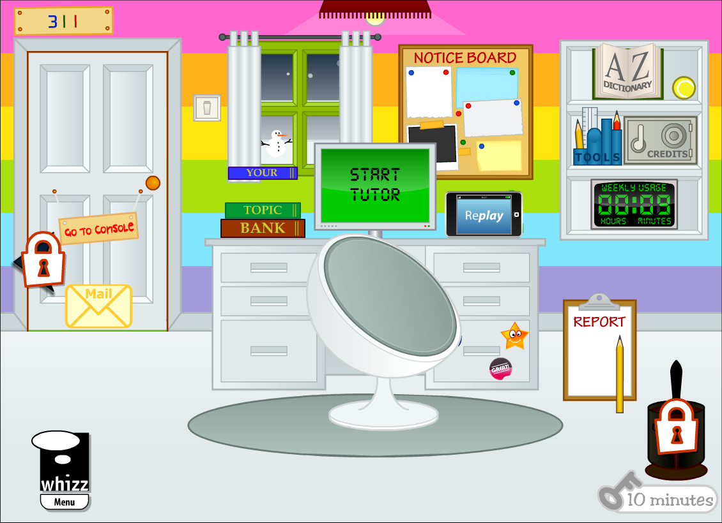

### 5.2 Console

Console is a more mature-looking area of the Student Experience, ideal for older users. It also contains leader-boards and access to Tutor and Replay.

### 5.3 Topic Bank and Replay

Students acquire new knowledge in Tutor, and they can consolidate knowledge in Topic Bank and Replay.

* Topic Bank gives them access to lower-age exercises, down to ¾ years in each topic from where they currently are in Tutor.
* Replay allows students to complete exercises already passed in Tutor, and encourages them to increase their performance (score and speed). Students can earn medals for improving their performance on these lessons. They can also Challenge other Maths-Whizz users around the world from here.

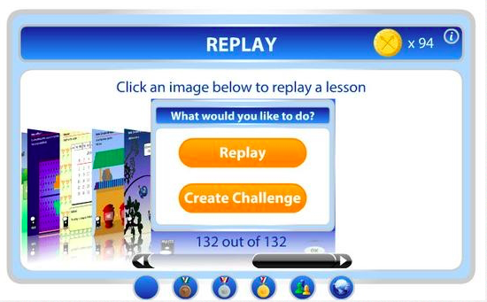

### 5.4 Challenge, Leaderboards and Buddies

When the student selects "Create Challenge" in Replay, the system searches for other students who have completed the lesson with a better score and time than the student. It orders them by ascending score and descending time and picks the first 3. This means that the opponents are the next students with the closest higher score and quickest time. This ensures students are challenging a performance similar to their own. A leaderboard displays the student and buddies, who have also done the exercise, time and score.

Students can add up to ten ‘Buddies’, who are then ranked according to Credits (this week and total), which reflects effort as well as progress. Students can also see a leaderboard for students across their school, and the whole of Whizz World.

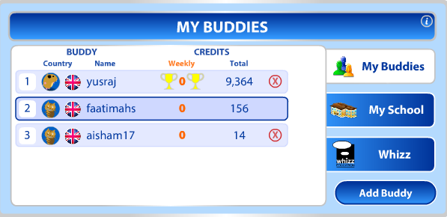

### 5.5 Credits

Credits are the currency of reward in Maths-Whizz, providing students with powerful motivation to drive their effort and achievement. Credits are awarded to students based upon their performance in an exercise or test.

Students can earn up to 15 credits for a tutor exercise, 30 credits for a test and 10 credits for a Replay exercise.

They also earn credits for achieving weekly usage milestones (30 minutes = 25 credits, 45 minutes = 50 credits, 60 minutes = 100 credits).

### 5.6 Shop, Play Area and Lock

Students can spend their credits in the Maths-Whizz virtual shop to buy pets, plants and toys, which they can then access in the Play Area. They must feed their pets or risk having them ‘donated to the Whizz zoo.’ This is a popular aspect of Maths-Whizz. To ensure students stay focused on task, a lock has been introduced and students can only access the Shop and Play Area when they have completed 10 minutes in their current session (or 45 minutes for the week).

### 5.6 Weekly Usage Journey

Short-term goals are important, and students are encouraged to meet usage and progress targets (at least 30 minutes and 3 Progressions) each week. The visual journey appears when students log in, and in between every exercise or test attempt.

## 6. Reports

The Tutor captures each student’s key learning interactions as they happen and feeds back real-time reports, which are available to parents (in the Parent Dashboard) and Teachers (in the School Reports).

### 6.1 Reporting period and Timespan

Every report focuses on a reporting period. All totals and averages are with respect to that period. Within a given period, the student will have been active for either the whole period, or just part of it if their first assessment was completed after the start of the reporting period. For a student and a reporting period:

**Timespan =** length of time student was active during the chosen period (in years, to 2dp)

There are six types of reporting periods:

* **Since Last Assessment:** shows data going back to the date the student’s most recent assessment was completed. If looking at a group of students, it calculates their individual values based on their respective most recent assessment dates.
* **Full History:** shows data going back all the way to the date the first assessment was completed.
* **Current Academic Year:** shows data going back to September 1 of the previous year.
* **Last 7 days:** shows data going back the present day, and all six days prior
* **Topic Focus period**: shows data going back to the moment the current Topic Focus was set.
* **Custom Dates:** shows data between the two dates you set.

If a student was not active during the period (i.e. their first assessment was not completed by the end date), they are ignored in the reports and greyed out. This is common when schools first sign up to Maths-Whizz, as students take some time to complete the initial assessment.

Once students have completed the initial assessment, they have a Maths Age and are included in any reporting period that contains the date they completed the initial assessment.

### 6.2 Key metrics

The most important metrics in the Maths-Whizz reports are:

* **Maths Age:** calculated per topic for each student. An overall Maths Age is also calculated as the arithmetic mean of the Topic Ages. For a Topic, Maths Age reflects the student’s assessment and learning journey to date and denotes precisely where they are in that Topic, e.g. a Maths Age of 7.6 in Place Value means the student has completed three-fifths of the lessons appropriate to Age 7. Maths Age increments every time a student moves along in the Topic.
* **Usage (weekly average):** the average time spent each week, in minutes, on Maths-Whizz. Usage refers to all time spent in exercises (including the Teaching Page) and tests. It also includes time spent in Replay and Topic Bank. Lessons that are incomplete in Tutor count towards Usage but this is not yet true of Replay and Topic Bank.
* **Progressions (weekly average):** a student makes a progression when they complete a new learning objective in Tutor, which usually means passing the exercise and test (or just the exercise if there is no test). If a student is in regression, they may have to pass several exercises and tests to get back to the initial learning objective. When they pass that learning objective, it only counts as 1 Progression.

Other important metrics:

* **Timespan:** see above
* **Maths Age Improvement:** shows how much the student has improved their Maths Age by during the period (be aware that reassessments can lead to very high or negative Improvements).
* **Average exercise/test score:** the average score in exercises/tests attempted in Tutor during the period.
* **Progression pass rate:** percentage of attempts at making a Progression (usually a test) that were successfully completed during the period. The global benchmark is 70%.

### 6.3 Student Reports

The Student Dashboard shows summaries around the three key metrics of Maths Age, Usage and Progressions.

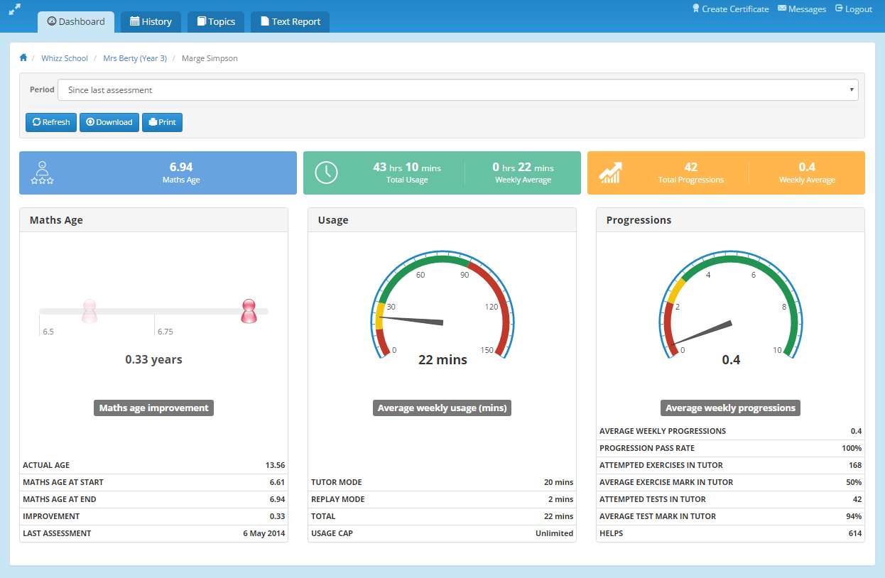

**Lesson History** includes a full record of every exercise or test the student has completed in Tutor and Replay. Here, Replay refers to any exercise completed in Replay or Topic Bank.

Incomplete and Jumped exercises are denoted by icons on the left, and failed exercises and tests are highlighted in red. The exercise or test can be clicked into on the right and used as practice ahead of its next appearance in Tutor.

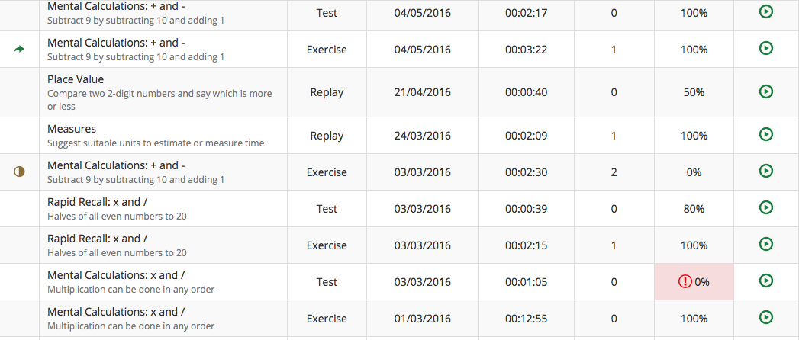

Lesson History also has an entry for every assessment completed within the period.

The student’s **Topic Profile** shows where they started, and how much they have improved, in each Topic during the reporting period.

The **Text Report** is a written summary of the student’s progress during the reporting period.

### 6.4 Parent reports

Parents can access student reports for each of their students. The reports are as above, though they are currently presented in Flash rather than HTML. Parents will only have access to live reports if the school has T++, or the parent has subscribed for £29.99.

### 6.5 Calculating for groups of students: Averages

For any group of students (class, school or beyond), averages are calculated by treating the students as a single group. For example, in a school with 5 classes, to calculate the overall average Maths Age we add up all the Maths Ages across the school and divide by the number of students. This gives us a more representative view of the whole school than simply averaging each of the five average class Maths Ages, as it is not skewed by large or small class sizes.

### 6.6 Class Reports

The Class Dashboard is a snapshot view of the top performers during the reporting period, and strongest/weakest topics for the class.

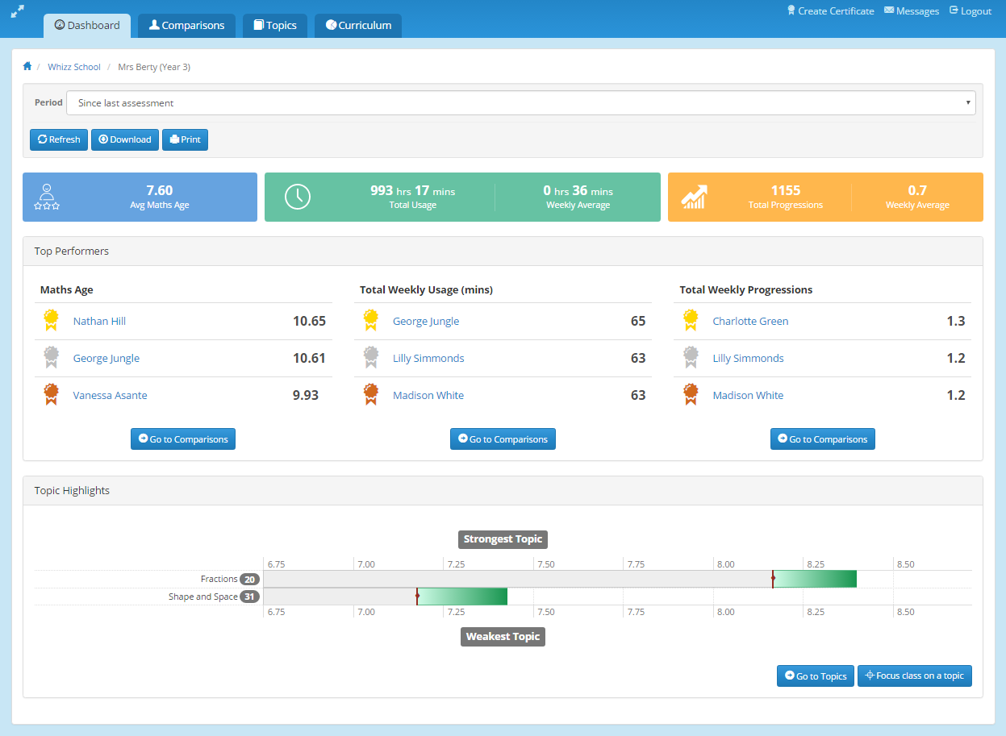

The **Comparisons** tab shows the distribution of Maths Age in the class (great for visualising the multi-year gap). The default table also lists Usage and Progressions (as weekly averages), and the distribution for each of these can also be viewed. The Detailed view brings up more specialised metrics, such as the breakdown of Usage into Tutor vs Replay.

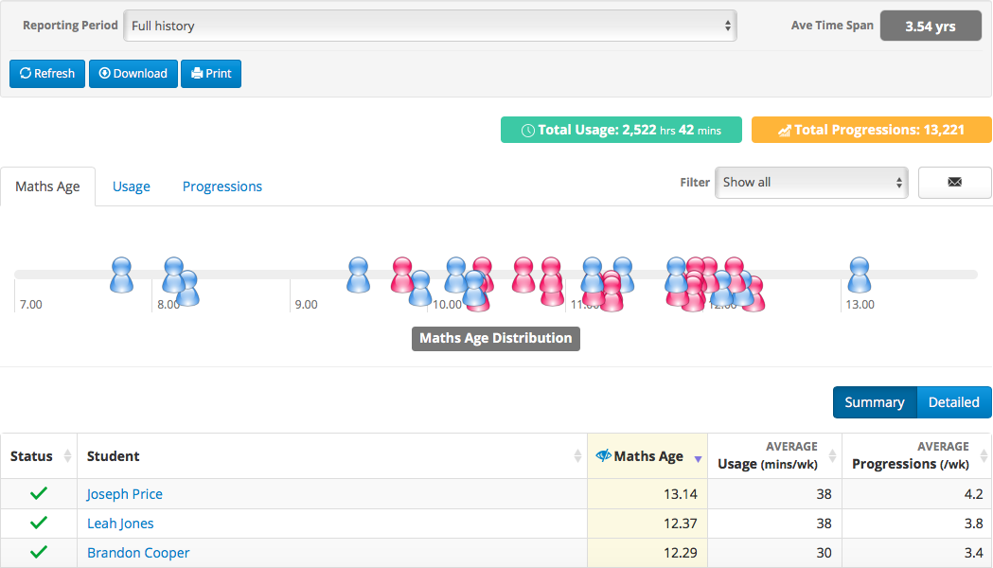

**Topic**s shows the learning profile for the whole class by topic, giving visibility on the progress made in each topic, as well as the average overall Maths Age. For some Topics, only a subset of students in the class will have registered a Maths Age (e.g. higher-age Topics, which some students may not have reached yet). The number of students covering each Topic is signified next to the Topic name, and the default view only shows Topics for which a majority of students have a Maths Age (the full view is a click away).

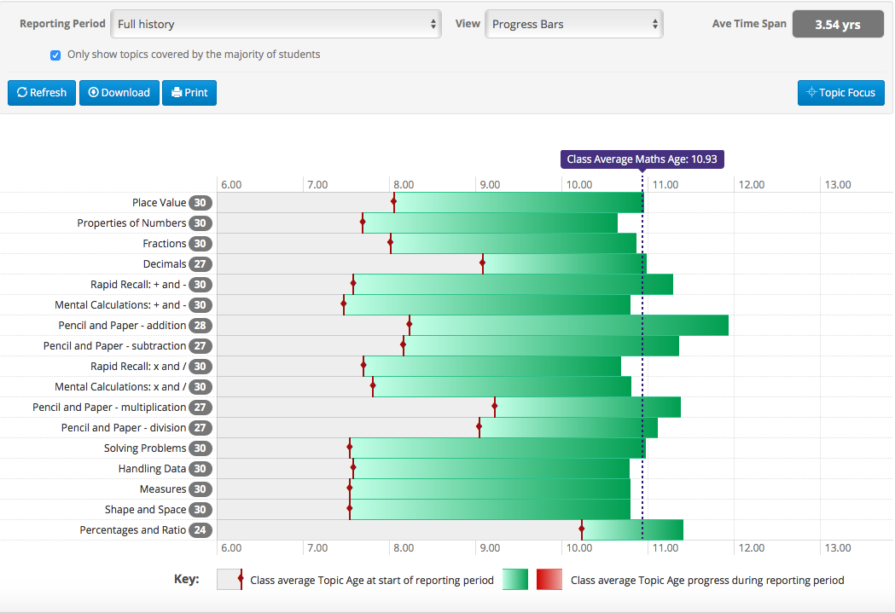

**Curriculum Reports** show progress with respect to the 2014 National Curriculum for England. Our educationalists broke the curriculum into over 300 standards, in line with the national guidelines. For each year you can see the domains and standards.

For each standard, you can bring up a list of learning objectives covered and not covered by Maths-Whizz. You can also see, for each student in the class, how many of the covered learning objectives they have completed.

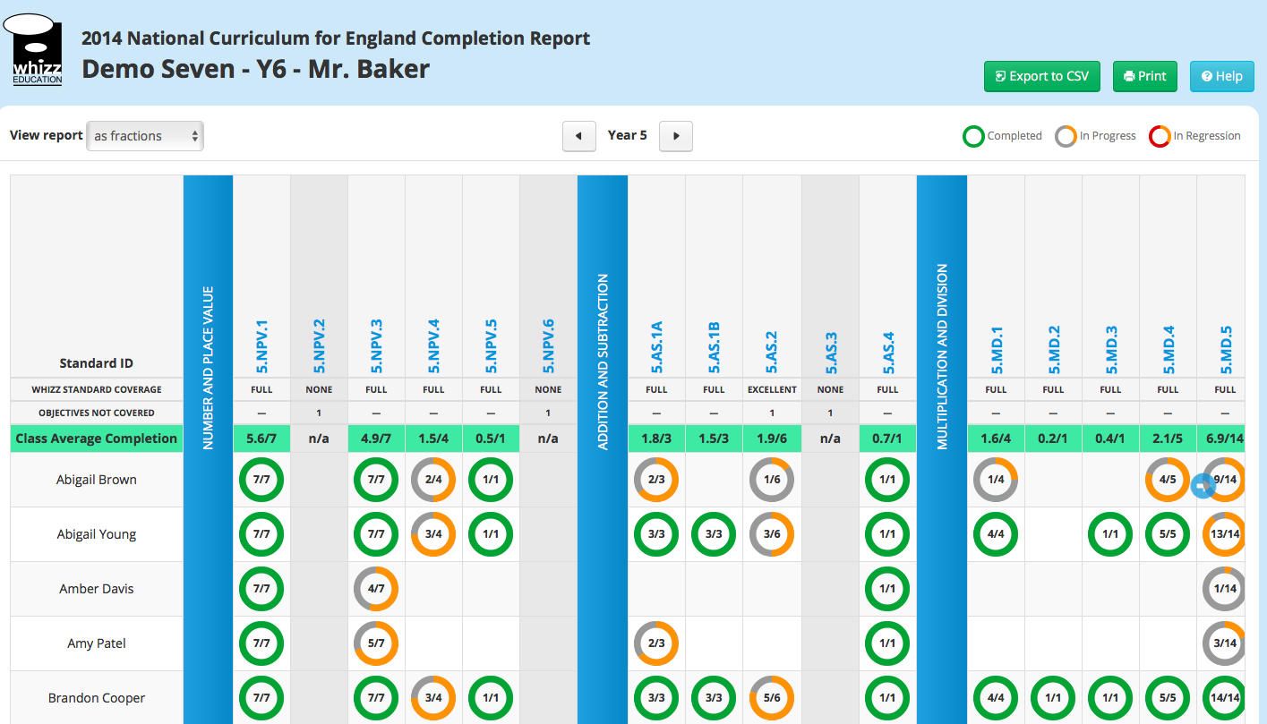

### 6.7 School reports

The School Reports provide a similar summary and comparison to Class reports, except now the comparison is between classes.

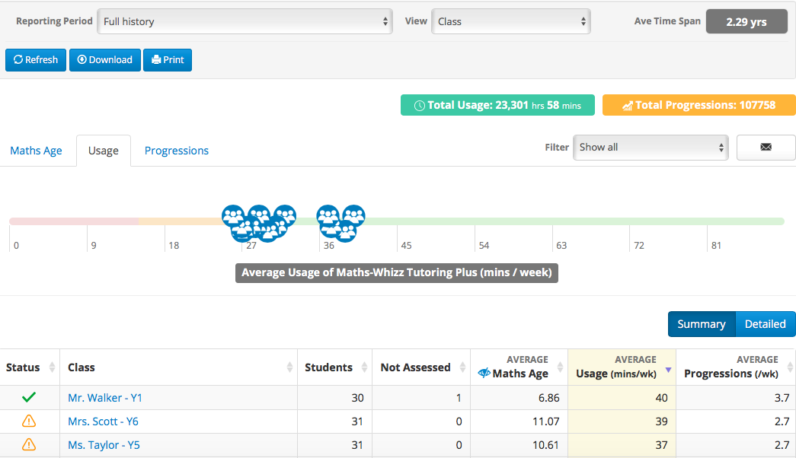

### 6.8 Central Reports

Central Reports show summaries and comparisons between schools, and even between groups of schools. It has two main uses:

* A way for MATs and other school groups to monitor progress across their student base.
* A real-time monitoring tool for Advisors and CSMs, each of whom has a login that lists all your schools (the UK Schools login similarly lets us compare usage and progress between different regions).

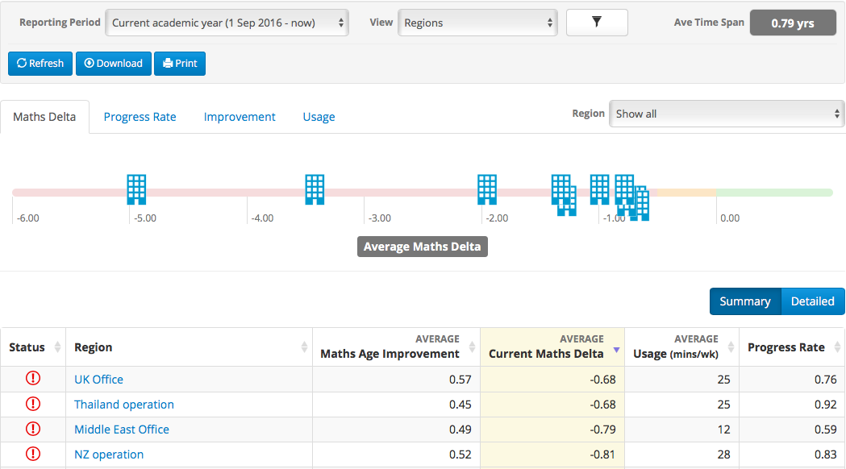

School Reports can be accessed for all schools that show in the Central Reports interface (e.g. for the UK Schools login, reports for all schools in the UK can be accessed individually).

Central Reports include two metrics not seen on the school reports:

* **Progress Rate:** this represents the pace of learning and is calculated as Maths Age Improvement/Timespan. A Progress Rate of 1 means the student is progressing at the expected rate; >1 means they are accelerating and <1 means they are not making the expected progress.
* **Delta:** every student has a Maths Age and an Actual Age. Delta is the difference: a Delta of zero means the student is currently at the expected overall level in maths, >0 means they are above the expected level and <0 means they are below.

As with most metrics, Progress Rate and Delta are most useful for comparisons – they can both be used to compare groups of students across different year groups. They should not be interpreted so literally.

### 6.9 Filters

Central Reports includes a range of filters that allow you to view data for subsets of students. The most common filter is Usage, which allows you to view data for students within different usage brackets. Gender can also be filtered on, and a range of custom filters are being added over time.

### 6.10 Key Actions

The reports are designed to help teachers plan their lessons. That’s why they have a number of actions built in to go with the data. The main examples are:

* **Printing certificates** and **sending messages** to high achieving students (listed on the class dashboard).

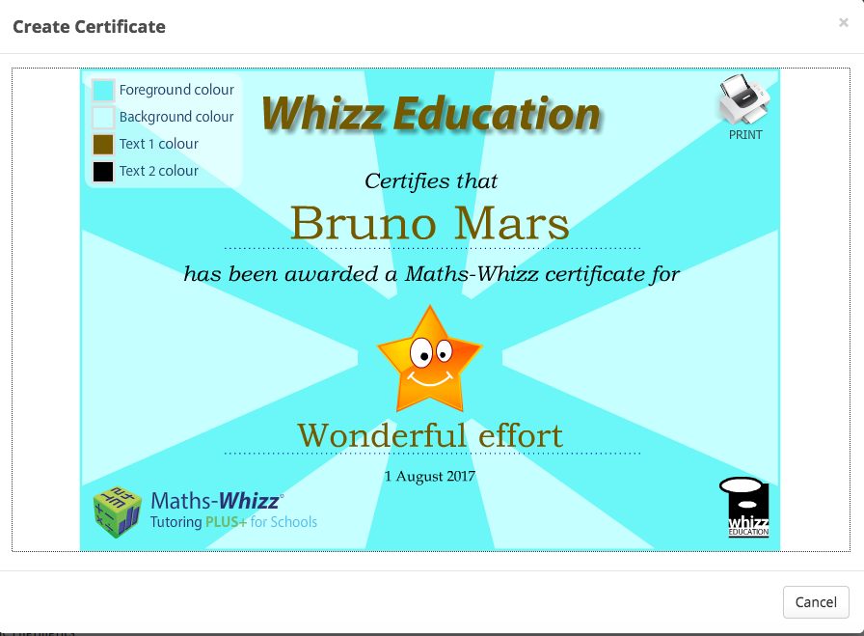

* **Topic Focus:** directing the Tutor to a topic via the Class Dashboard or the Class Topics page.
* **Bring up lessons**: either via Lesson History (useful for intervention for lessons flagged up as having been failed) or the Curriculum Reports.
* **Printing reports:** all key reporting pages can be printed – useful for parents’ evenings and for fulfilling other reporting requirements.

### 6.11 Automated fortnightly emails

Automated email reports are sent every two weeks, first thing Monday morning. These emails summarise progress across the school. There are three types of emails; the type sent depends on the usage and progress across the school. Emails may include a full list of classes, or just a highlighted class, or Top Tips (or a combination). They focus on Usage and Progressions in the previous two weeks.

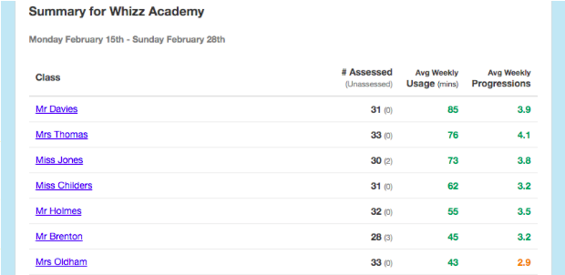

The School Emails are sent no earlier than six weeks after the school’s start date on Maths-Whizz (this leaves time for onboarding, assessment and manual CS emails).

Emails are opt-in: CSMs must add details of schools they want to include to a list that is maintained by Product. CSMs may also send names of contacts at those schools who they do not want to receive the emails; Product will add those contacts to an Unsubscribe list, which can be reverted at any time.

### 6.12 Usage and Progressions guidelines

Whizz recommends 45-60 minutes of usage each week. This is based on historical data that suggests students within this usage band will accelerate their learning in the first year. Specifically, we expect students with 60 minutes of usage to improve their Maths Age by 18 months in the first year. Students tend to make the expected progress (Maths Age Improvement of 1 year in the first 12 months) with 30 minutes per week. Full details are in the Maths-Whizz Proof Pack.

This recommendation has two important caveats:

* It is based on an overall average and may need to be adjusted to the needs of the individual school, class or student (e.g. intervention students may need more than 60 minutes to make the 18-month progress).
* It relies on productive usage of Maths-Whizz; the learning gains won’t be observed if too much time is wasted on incomplete lessons or in Replay/Topic Bank (in general, 10-15 minutes per week should go into consolidation, again adjusted for the individual student).

Progressions are a good way of tracking if students are making the expected progress, and are much more tangible to measure from one week to the next. In general, students should be making 3 Progressions/week. This has the same caveats as above, as well as the following:

* It is based on annual usage, including holidays, so term-time Progressions may need to be higher to account for lower holiday usage.
* Students with a lower Maths Age may not need as many as 3 Progressions each week. Likewise, those with a higher Maths Age may need more than 3 Progressions each week. This is due to there being fewer learning objectives in the lower years of the Maths-Whizz curriculum.

Usage is a good measure of students’ effort, and Progression is a good measure of their understanding. Together they paint a reliable picture of the student’s overall progress on Maths-Whizz.

## 7. Teachers’ Resource

Teachers’ Resource (TR) contains a range of tools and resources to support teachers and students in the classroom. TR can be used for whole-class or small-group instruction and is the perfect complement to the Tutor and other online and offline resources.

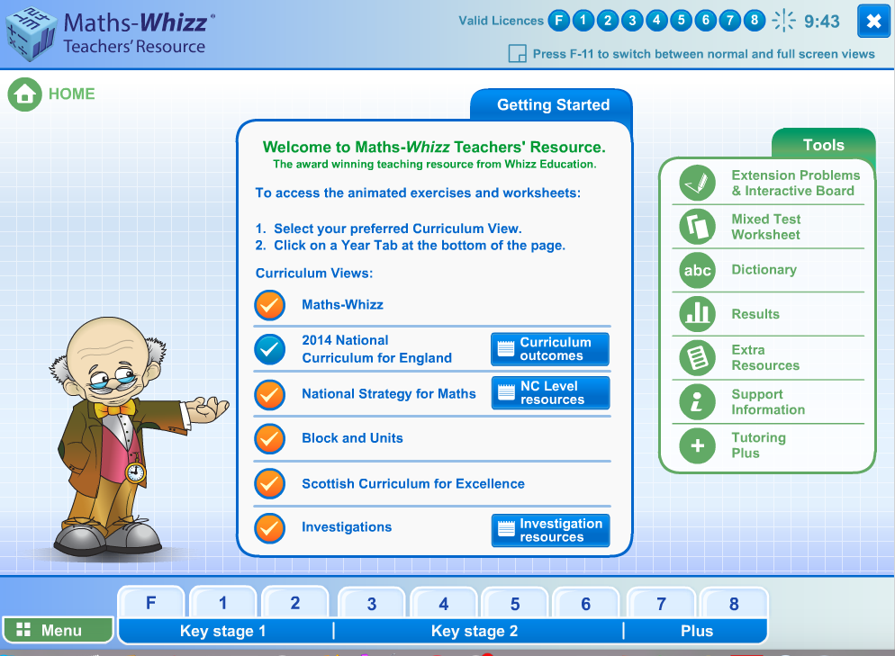

Schools get a site-wide license to TR regardless of how many Tutoring licenses they purchase. Schools can create a desktop shortcut, making it easy to access TR. Students can access TR but not via their logins, so their progress is not tracked (that is what the Tutor is for.)

TR used to be sold as a standalone product and many schools still have access to TR only today.

### 7.1 Lessons

All 1250 lessons are available, including the interactive exercises and tests (which are presented as printable worksheets). The lessons are organised according to different curricula, including the underlying Maths-Whizz curriculum and the National Curriculum for England.

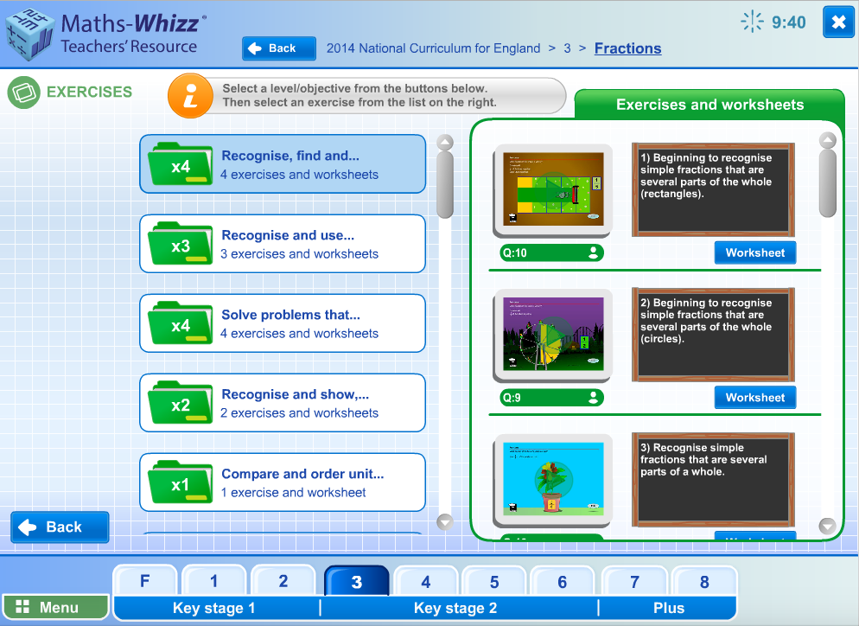

### 7.2 Mixed Tests

Teachers can create custom tests, selecting up to 4 topics and, for each topic, a grade and difficulty level (which corresponds to the quarter of the chosen grade: Level A is the first quarter, Level D the fourth quarter etc). Mixed Tests can support both formative and summative assessment. Teachers can print Mixed tests with or without the answers.

### 7.3 Interactive Board and Extension Problems

The Interactive Board is a digital whiteboard, with a range of maths manipulatives. Teachers can create and save tasks.

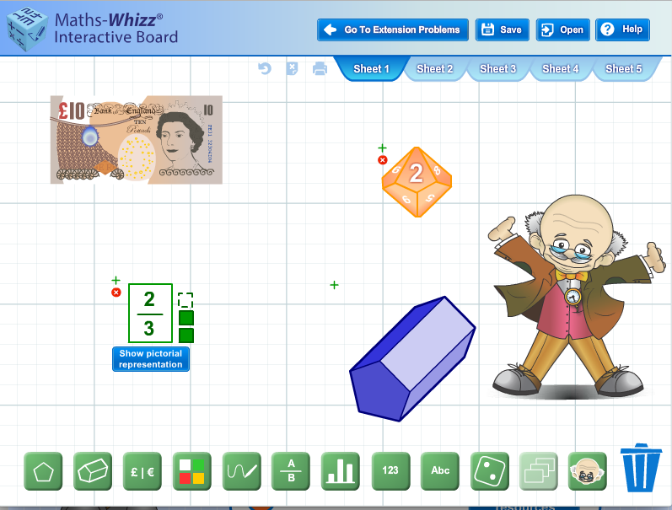

Extension Problems have been created in the Interactive Board to support deeper learning, helping students to apply and build on the knowledge they have acquired in Tutor. The Extension Problems are arranged in 3 stages (Lower Primary, Upper Primary, Early Secondary) and are ‘low-floor, high-ceiling’, meaning they are suitable for most students, but contain several layers of depth for higher attainers. Every Extension Problem has a downloadable Teacher Handout and, where appropriate, solution template.

### 7.4 Examples of other tools

Teachers can also explore real-world tasks through Investigations, and look up vocabulary through the Dictionary.

## 8. Parent Experience

## Parents have two options to be involved with their child’s learning on Maths-Whizz which will contribute to the school’s success via the “triangle of success” (students, teachers, parents):

* **Free Monthly Emails:** Parents can register to receive free update emails. These are sent on the first Monday of every month, and give them an overview of the progress their child is making with Maths-Whizz.
* **Parent Dashboard:** To access detailed live reports that show their child’s progress, effort and attainment as they learn with Maths-Whizz, they can subscribe to a Parent Dashboard for an additional cost (private schools will have this incorporated into their subscription cost)

To register for free emails or sign up for a Parent Dashboard, the parent logs into their child’s account and goes to ‘Console’. They then must click on the orange ‘parents’ button, and follow the simple on-screen instructions.

Customer Success team organise parent sessions for schools where they inform parents of the value of Maths-Whizz and drive them to register for one of these two options. Literature is also available to parents:

* **Parent leaflets:** gives a brief summary of Maths-Whizz and what parents can do to support their child. This is handed out at parent sessions
* **Parent letters:** for schools to send out to parents once they have subscribed to Maths-Whizz.

## 9. Admin

When teachers log into their school account, they can Manage Classes and Upload Students.

* All admin can be done via the Manage Classes button (green button under the School Report).
* Teachers are able to bulk upload students, move students between classes, activate and deactivate their accounts and archive students year to year. This is also where teachers can find students’ usernames and passwords.

## 10. Technology

## The student experience runs on flash, which means Adobe Flash must be installed on the computer for it to function. Browsers will sometimes ask for the Flash plugin to be enabled.

## The Tutoring+ Reports work via HTML therefore teachers can use the Reports on any device.

## iPads/Tablets

Maths-Whizz can be used on iPads through a free educational app called Puffin Academy. This can be downloaded from any app store. Once downloaded, all you have to do is open the browser, click on the Puffin Academy Portal and search for Maths-Whizz, then click install. Now Maths-Whizz will be installed on the iPad or tablet in the Puffin Academy Browser, and can be accessed at any time.

For the best learning experience, we do advise that children use Maths-Whizz on a laptop or computer, anywhere they have access to the internet they will be able to log in to Maths-Whizz.